Project Design Phase-II
Technology Stack (Architecture & Stack)

Date
Team ID
Project Name | PocketSmart AI: Your Smart Budget & Recommendation Assistant
Maximum Marks

Technical Architecture:
The PocketSmart AI technical architecture includes the architectural diagram and the technology details required for the Smart Budget and Recommendation Assistant, as provided in Table 1 and Table 2. 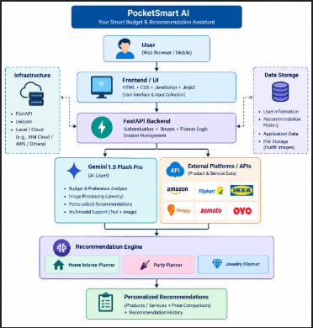

Table-1 : Components & Technologies:
S.No | Component | Description | Technology
1. | User Interface | Users enter budget, preferences, event details, room details and optional outfit images and view recommendations. | HTML, CSS, JavaScript, Jinja2
2. | Application Logic-1 | Handless home,party and jewelry planner request. | Python, FastAPI
3. | Application Logic-2 | Processes user budget, preferences and context to generate recommendations | Gemini 1.5 Flash Pro
4. | Application Logic-3 | Handles user registration, login, logout and session management. | FastAPI, JWT
5. | Database | Stores user information and recommendation history. | Database
6. | Cloud Database | Stores application data in a cloud environment if required. | Not Specified
7. | File Storage | Stores uploaded outfit images for jewelry recommendations. | File Storage
8. | External API-1 | Provides product and home interior recommendations. | Amazon, Flipkart, IKEA.
9. | External API-2 | Provides food, venue, and accommodation recommendations. | Swiggy, Zomato, OYO
10. | Machine Learning Model | Analyzes budget, preferences, and images to generate personalized recommendations. | Gemini 1.5 Flash Pro
11. | Infrastructure (Server / Cloud) | Supports backend execution and application deployment. | FastAPI, Uvicorn, Local/Cloud

Table-2: Application Characteristics:
S.No | Characteristics | Description | Technology
1. | Open-Source Frameworks | Provides the frameworks and technologies used to develop the PocketSmart AI application. | Python, FastAPI, HTML, CSS, JavaScript, Jinja2
2. | Security Implementations | Protects user access and manages secure communication between the application and services. | Authentication, Session Management, CORS
3. | Scalable Architecture | Uses a modular architecture to handle different recommendation modules such as Home, Party, and Jewelry. | FastAPI, Python
4. | Availability | Provides recommendation services through the application and external service integrations. | Technology used
5. | Performance | Processes user requirements and generates personalized recommendations efficiently. | Fast API, JavaScript, Gemini 1.5 flash pro

